LAB # 01

INTRODUCTION TO MSP43O MCU AND INSTALLATIONS OF HARDWARE

AND SOFTWARE TOOLS



Spring 2025

CSE-307L

Microprocessor Based System Design Lab

Submitted by: Naveed Ahmad

Registration No.: 22PWCSE2165

Class Section: B

Student Signature: ______________

Submitted to:

Engr. Shah Zada Fahim Jan

March 08, 2025

Department of Computer Systems Engineering

University of Engineering and Technology, Peshawar

**Lab Tasks:**

***Task 1***

***Write a C Program for MSP-430 which toggle P1.0 or any other pin of MSP-430 MCU* Code*:* 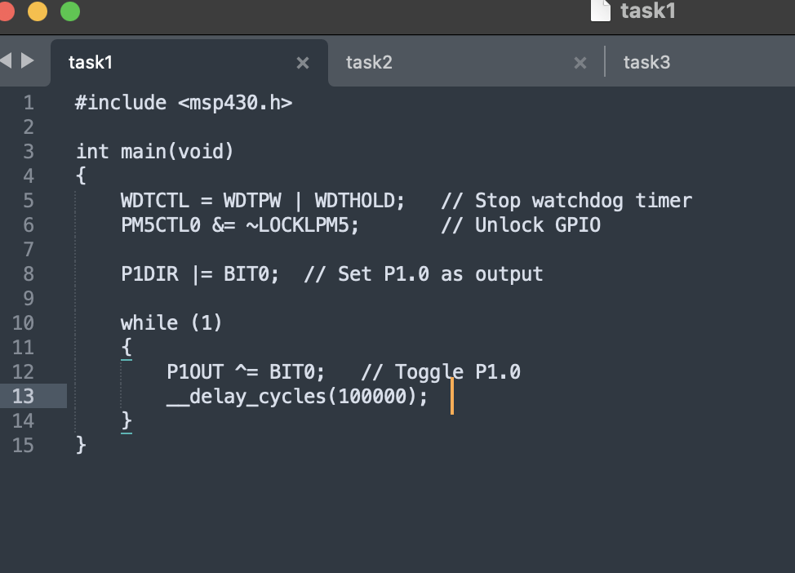**

Output:

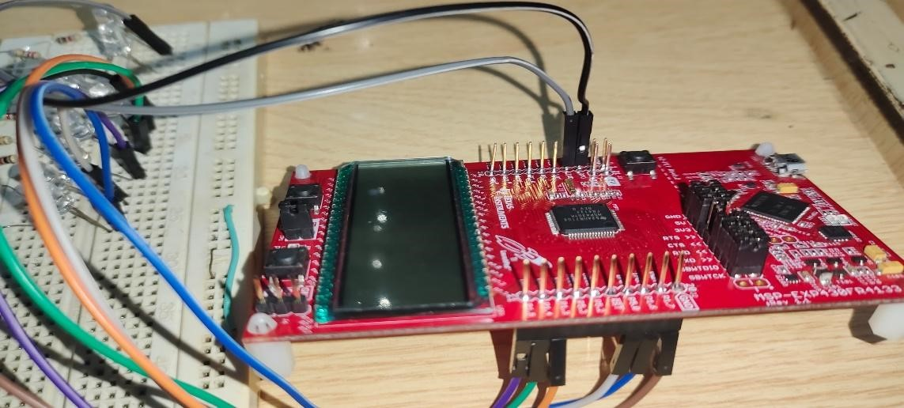

**Task 2**

*Write a C Program for MSP-430 which toggle P4.0 for MSP-430 FR4133 or any other pin of MSP-430 MCU*

**Code:** 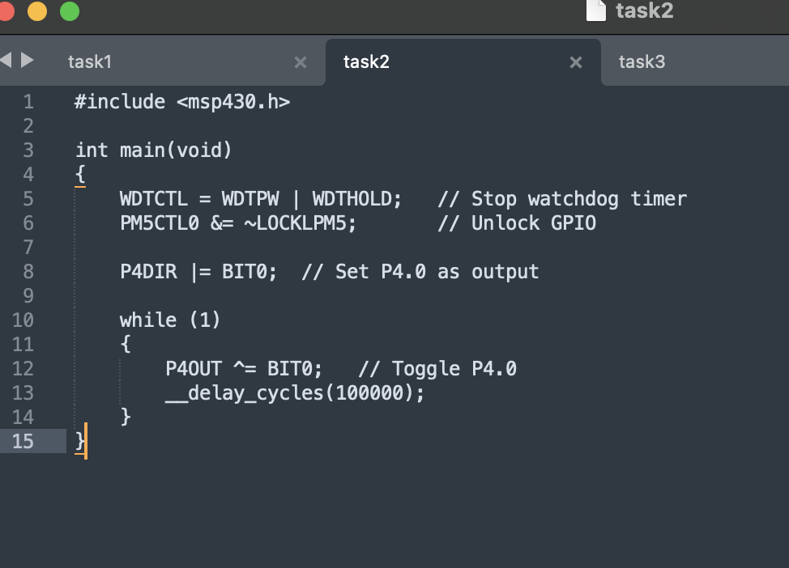

**Output:**

**Task 3**

**Write a C Program for MSP-430 which toggle P5.1 for MSP-430 FR4133 or any other pin of MSP-430 MCU Code:**

**Output:**

**Task 4**

***Write a C Program for MSP-430 which toggle P1.1 for MSP-430 FR4133 or any other pin of MSP-430 MCU***

**Code:**

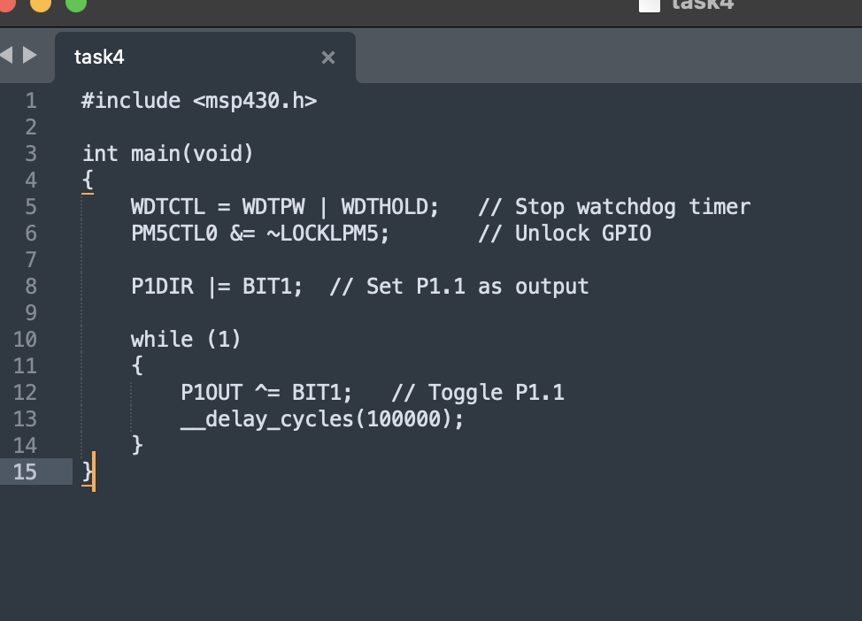

**Output:**

